Assignment Description

A console-based library management system written in C++. You are able to view and store book based transactions while tracking the checkouts, returns and even the patrons of the associated transactions.

1 Readme Documentation

Build and run
g++ -std=c++17 -Wall -Wextra -o library main.cpp Library.cpp Book.cpp Patron.cpp Transaction.cpp Date.cpp
.\library.exe (Windows)
Run the program from the folder that contains books.txt and patrons.txt. transactions.txt is created automatically the first-time data is saved (menu option 0).
Inputs
• books.txt – Genre,Title,Author,Printed|EBook,PageCount|FileSizeMB[,Available|CheckedOut] e.g. Fiction,The Great Gatsby,F. Scott Fitzgerald,Printed,180,Available
• patrons.txt – ID,Name[,Title1|Title2] (optional third field lists books the patron currently has out) e.g. 1,Jane Doe
• transactions.txt – PatronID,Title,CHECKOUT|RETURN,Date,DueDate (loaded on start; rewritten on save). Dates use YYYY-MM-DD.
• Keyboard – The user types a menu number, then answers prompts (patron ID, book title, author/genre text, new book or patron details). Invalid numbers, empty text, unknown genres, and text containing commas are rejected with an error message instead of crashing. Menu options

Option | Action | Prompts
1 | View All Books (title, author, genre, status, format details) | none
2 | View All Patrons and the Books out | none
3 | Check Out a Book (due date = today + 14 days) | Patron ID, book title
4 | Return a Book | Patron ID, book title
5 | Add a New Book (Printed or EBook) | Title, author, genre, format, pages or MB
6 | Add a New Patron | Patron ID, name
7 | Search Books by Author (case-insensitive, partial match) | Author text
8 | Search Books by Genre (case-insensitive, partial match) | Genre text
9 | View the Transaction Log | none
0 | Save all data to the files and exit | none
Outputs
• On screen – formatted book, patron, search, and transaction listings; confirmation messages such as “Tony Montana checked out ‘Educated’. Due: 2026-10-29”; and “Error: …” messages for any failed operation.
• Files – books.txt (including each book’s status), patrons.txt (including borrowed titles), and transactions.txt are rewritten on Save and Exit, so the state carries over to the next run. Closing the program any other way loses that session’s changes.
Input rules
• Genre must be Fiction, NonFiction, Mystery, Science, or Biography; format must be Printed or EBook.
• Titles, authors, and names cannot contain commas (the data files are comma-separated).
• Book titles are matched ignoring upper/lower case. The genre search uses the displayed name, so type Non-Fiction (with the hyphen) to find non-fiction books.
• A patron may have at most 5 books out, patron IDs must be unique, and the same book (title and author) cannot be added twice.
Error handling (exceptions)
• File problems – missing books/patrons files; malformed records (reported with file name and line number).
• Invalid transactions – BookNotFoundException, PatronNotFoundException, BookUnavailableException, and DuplicateException (all derive from std::runtime_error); borrowing-limit (5 books) and “not borrowed by this patron” errors; std::invalid_argument for bad input.
How the requirements are met
Requirement | Implementation
4+ classes | Book, Patron, Transaction, Library, Date
Inheritance | EBook and PrintedBook derive from Book
Polymorphism | Virtual displayInfo(), getType(), getExtra() overridden in the child classes; Library calls them through Book*
Encapsulation | Private/protected data members with public accessors and methods
Operator overloading | operator== and operator<< for Book and Patron (also == and < for Date)
Exception handling | Custom exceptions in LibraryExceptions.h; try/catch in main() and the menu loop
Collections | std::vector<Book*>, std::vector<Transaction>, std::map<int, Patron>
File I/O | Library::loadData() / saveData() read and write the books, patrons, and transactions files
Enumerations | enum class Genre and enum class BookStatus (Book.h)
Templates | saveToFile<T>() and loadFromFile<T>() in FileIO.h

2 Flowchart Screen Shots or Pseudocode

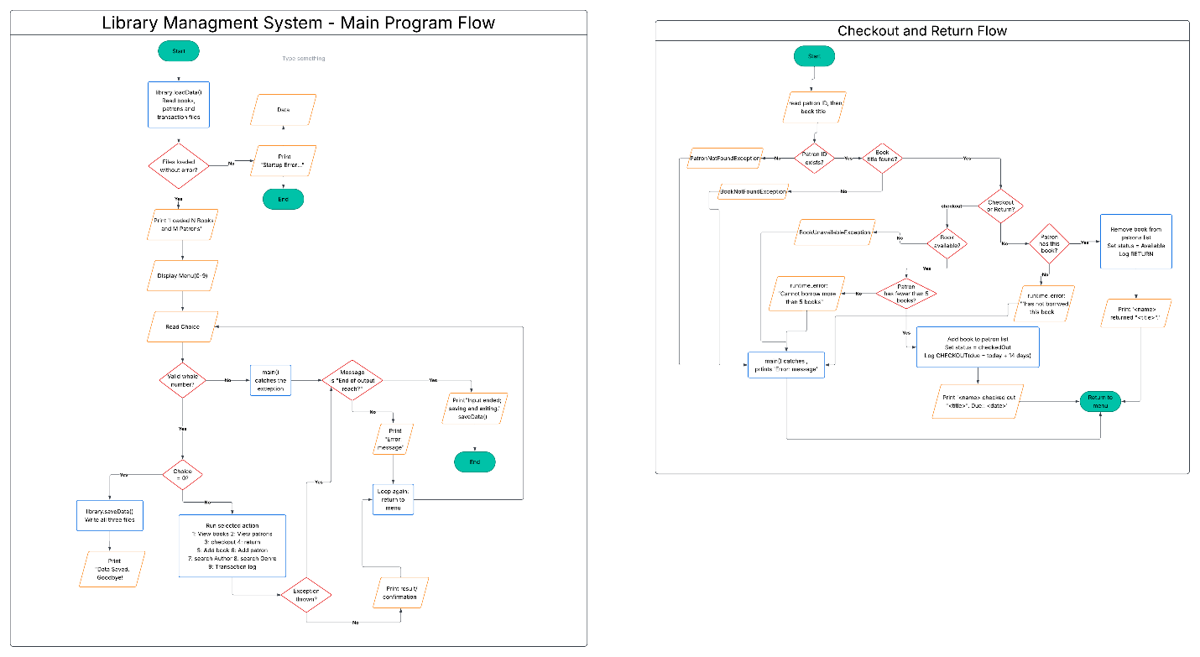

3 UML and Use Case Diagrams
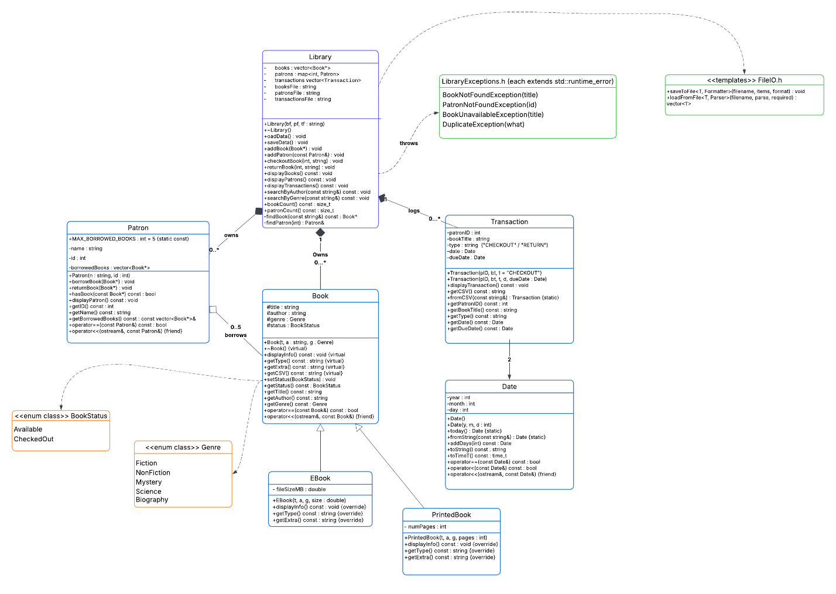
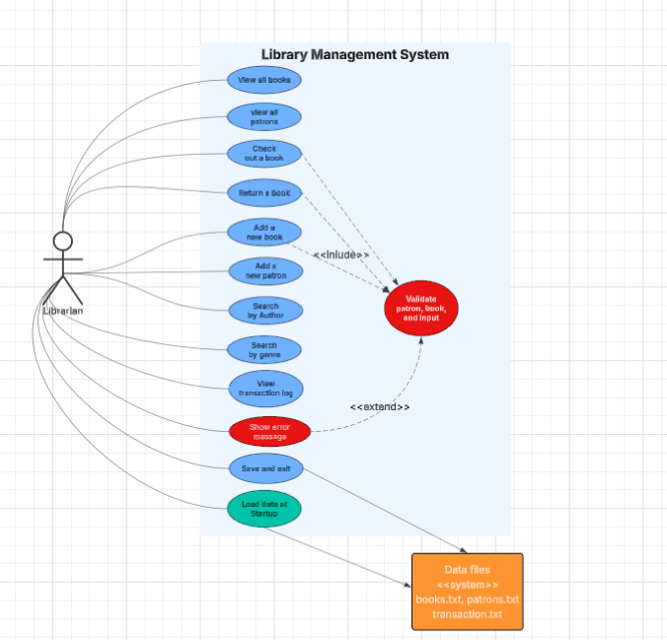
Required: UML Class and Use Case Diagram Screenshots

4 Source Code of All files (.h, .cpp)

Book.cpp
#include "Book.h"
#include <sstream>
#include <iomanip>
#include <stdexcept>
using namespace std;

string genreToString(Genre g) {
switch (g) {
case Genre::Fiction: return "Fiction";
case Genre::NonFiction: return "Non-Fiction";
case Genre::Mystery: return "Mystery";
case Genre::Science: return "Science";
case Genre::Biography: return "Biography";
}
return "Unknown";
}

Genre stringToGenre(const string& s) {
if (s == "Fiction") return Genre::Fiction;
if (s == "NonFiction") return Genre::NonFiction;
if (s == "Mystery") return Genre::Mystery;
if (s == "Science") return Genre::Science;
if (s == "Biography") return Genre::Biography;
throw invalid_argument("Unknown genre: " + s);
}

string statusToString(BookStatus s){
return (s == BookStatus::Available) ? "Available" : "CheckedOut";
}

Book::Book(string t, string a, Genre g)
: title(move(t)), author(move(a)), genre(g), status(BookStatus::Available) {};

void Book::displayInfo() const{
cout << left << setw(32) << title << setw(24) << author << setw(12) << genreToString(genre) << setw(12) << statusToString(status) << endl;
}

string Book::getType() const{
return "Book";
}
string Book::getExtra() const{
return "";
}

string Book::getCSV() const {
return genreToString(genre) + "," + title + "," + author + "," + getType() + "," + getExtra()+ "," + statusToString(status);
}

void Book::setStatus(BookStatus s){
status = s;
}
BookStatus Book::getStatus() const{
return status;
}
string Book::getTitle() const{
return title;
}
string Book::getAuthor() const{
return author;
}
Genre Book::getGenre() const{
return genre;
}

bool Book::operator==(const Book& other) const{
return title == other.title && author == other.author;
}

ostream& operator<<(ostream& os, const Book& b){
os << left << setw(32) << b.title << setw(24) << b.author << setw(12) << genreToString(b.genre) << setw(12) << statusToString(b.status);
return os;
}

EBook::EBook(string t, string a, Genre g, double size)
: Book(move(t), move(a), g), fileSizeMB(size) {
if (size <= 0) {
throw invalid_argument("File size must be positive");
}
}

void EBook::displayInfo() const{
Book::displayInfo();
cout << "EBook Size: " << fixed << setprecision(1) << fileSizeMB << " MB" << endl;
}

string EBook::getType() const{
return "EBook";
}

string EBook::getExtra() const{
ostringstream oss;
oss << fixed << setprecision(1) << fileSizeMB;
return oss.str();
}

PrintedBook::PrintedBook(string t, string a, Genre g, int pages)
: Book(move(t), move(a), g), numPages(pages) {
if (pages <= 0) {
throw invalid_argument("Number of pages must be positive");
}
}
void PrintedBook::displayInfo() const{
Book::displayInfo();
cout << "Printed Book Pages: " << numPages << endl;
}

string PrintedBook::getType() const{
return "Printed";
}
string PrintedBook::getExtra() const{
return to_string(numPages);
}
Book.h
#ifndef BOOK_H
#define BOOK_H

#include <iostream>
#include <string>
using namespace std;

enum class Genre { Fiction, NonFiction, Mystery, Science, Biography};
enum class BookStatus {Available, CheckedOut};

string genreToString(Genre g);
Genre stringToGenre(const string& s);
string statusToString(BookStatus s);

class Book {
protected:
string title;
string author;
Genre genre;
BookStatus status;

public:
Book(string t, string a, Genre g);
virtual ~Book() = default;

virtual void displayInfo() const;
virtual string getType() const;
virtual string getExtra() const;
virtual string getCSV() const;

void setStatus(BookStatus s);
BookStatus getStatus() const;
string getTitle() const;
string getAuthor() const;
Genre getGenre() const;

bool operator==(const Book& other) const;
friend ostream& operator<<(ostream& os, const Book& b);
};

class EBook : public Book {
private:
double fileSizeMB;

public:
EBook(string t, string a, Genre g, double size);
void displayInfo() const override;
string getType() const override;
string getExtra() const override;
};

class PrintedBook : public Book {
private:
int numPages;

public:
PrintedBook(string t, string a, Genre g, int pages);
void displayInfo() const override;
string getType() const override;
string getExtra() const override;
};

#endif
Date.cpp
#include "Date.h"
#include <iomanip>
#include <sstream>
#include <stdexcept>
using namespace std;

static bool validDate(int y, int m, int d){
if (y < 1900 || m < 1 || m > 12 || d < 1) {
return false;
}
static const int days[] = { 31, 28, 31, 30, 31, 30, 31, 31, 30, 31, 30, 31 };
int maxDays = days[m - 1];
bool leapYear = (y % 4 == 0 && y % 100 != 0) || (y % 400 == 0);
if (m == 2 && leapYear) {
maxDays = 29;
}
return d >= 1 && d <= maxDays;
}

Date::Date(){
time_t now = time(nullptr);
tm* localTime = localtime(&now);
day = localTime->tm_mday;
month = localTime->tm_mon + 1;
year = localTime->tm_year + 1900;
}

Date::Date(int y, int m, int d) : year(y), month(m), day(d) {
if (!validDate(y, m, d)) {
throw invalid_argument("Invalid date");
}
}

Date Date::today() {
return Date();
}

Date Date::fromString(const string& s) {
istringstream iss(s);
int y, m, d;
char sep1, sep2;
if (!(iss >> y >> sep1 >> m >> sep2 >> d) || sep1 != '-' || sep2 != '-' || !validDate(y, m, d)) {
throw invalid_argument("Invalid date format");
}
return Date(y, m, d);
}

time_t Date::toTimeT() const {
tm timeStruct = {};
timeStruct.tm_year = year - 1900;
timeStruct.tm_mon = month - 1;
timeStruct.tm_mday = day;
return mktime(&timeStruct);
}

string Date::toString() const {
ostringstream oss;
oss << setfill('0') << setw(4) << year << "-" << setw(2) << month << "-" << setw(2) << day;
return oss.str();
}

Date Date::addDays(int n) const{
static const int days[] = {31,28,31,30,31,30,31,31,30,31,30,31};
Date r = *this;
while (n-->0){
int maxDays = days[r.month - 1];
bool leap = (r.year % 4 == 0 && r.year % 100 != 0) || (r.year % 400 == 0);
if (r.month == 2 && leap) maxDays = 29;
if (++r.day > maxDays){
r.day = 1;
if (++r.month > 12){ r.month = 1; ++r.year;}
}
}
return r;
}

bool Date::operator==(const Date& other) const {
return year == other.year && month == other.month && day == other.day;
}

bool Date::operator<(const Date& other) const {
if (year != other.year) return year < other.year;
if (month != other.month) return month < other.month;
return day < other.day;
}

ostream& operator<<(ostream& os, const Date& d) {
os << d.toString();
return os;
}

Date.h
#ifndef DATE_h
#define DATE_h

#include <iostream>
#include <string>
#include <ctime>
using namespace std;

class Date{
private:
int year;
int month;
int day;

public:
Date();
Date(int y, int m, int d);

static Date today();
static Date fromString(const string& s);

Date addDays(int days) const;
string toString() const;
time_t toTimeT() const;

bool operator==(const Date& other) const;
bool operator<(const Date& other) const;
friend ostream& operator<<(ostream& os, const Date& d);
};

#endif
FileIO.h
#ifndef FILEIO_H
#define FILEIO_H

#include <fstream>
#include <string>
#include <functional>
#include <stdexcept>
#include <vector>
using namespace std;

template <typename T, typename Formatter>
void saveToFile(const string& filename, const vector<T>& items, Formatter format) {
ofstream file(filename);
if (!file) {
throw runtime_error("Failed to open '" + filename + "' for writing.");
}
for (const auto& item : items) {
file << format(item) << endl;
}
}

template <typename T, typename Parser>
vector<T> loadFromFile(const string& filename, Parser parse, bool required = true) {
ifstream file(filename);
vector<T> items;
if (!file) {
if (required) {
throw runtime_error("Failed to open '" + filename + "'.");
} else {
return items;
}
}
string line;
int lineNo = 0;
while(getline(file, line)){
++lineNo;
if (!line.empty() && line.back() == '\r'){
line.pop_back();
}
if (line.empty()) continue;
try{
items.push_back(parse(line));
}catch(const exception& e) {
throw runtime_error(filename + ", line " + to_string(lineNo) + ": " + e.what());
}
}
return items;
}

#endif
Library.cpp
#include "Library.h"
#include "FileIO.h"
#include "LibraryExceptions.h"
#include <algorithm>
#include <cctype>
#include <iomanip>
#include <iostream>
#include <sstream>
using namespace std;

static string lower(string s) {
transform(s.begin(), s.end(), s.begin(), [](unsigned char c) { return tolower(c); });
return s;
}

static vector<string> splitCSV(const string& line, char delim = ','){
vector<string> parts;
string field;
istringstream iss(line);
while (getline(iss, field, delim)) parts.push_back(field);
return parts;
}

static void printBookHeader(){
cout << left << setw(32) << "Title" << setw(24) << "Author" << setw(12) << "Genre" << setw(12) << "Status" << "Format / Details" << endl;
cout << string(90, '-') << endl;
}

Library::Library(string bf, string pf, string tf)
: booksFile(move(bf)), patronsFile(move(pf)), transactionsFile(move(tf)){}

Library::~Library(){
for (Book* b : books) delete b;
}

Book* Library::findBook(const string& title) const {
string key = lower(title);
for (Book* b : books)
if (lower(b->getTitle()) == key) return b;
throw BookNotFoundException(title);
}

Patron& Library::findPatron(int id) {
auto it = patrons.find(id);
if (it == patrons.end()) throw PatronNotFoundException(id);
return it->second;
}
const Patron& Library::findPatron(int id) const{
auto it = patrons.find(id);
if (it == patrons.end()) throw PatronNotFoundException(id);
return it->second;
}

static Book* parseBook(const string& line){
vector<string> f = splitCSV(line);
if (f.size()< 5) throw invalid_argument("Malformed book record: " + line);
Genre g = stringToGenre(f[0]);
Book* book = nullptr;
if (f[3] == "Printed") book = new PrintedBook(f[1], f[2], g, stoi(f[4]));
else if (f[3] == "EBook") book = new EBook(f[1], f[2], g, stod(f[4]));
else throw invalid_argument("Unknown book format '" + f[3] + "'");
if (f.size() >= 6 && f[5] == "CheckedOut") book->setStatus(BookStatus::CheckedOut);
return book;
}

struct PatronRecord{
int id;
string name;
vector<string> borrowed;
};

static PatronRecord parsePatron(const string& line){
vector<string> f = splitCSV(line);
if (f.size() < 2) throw invalid_argument("Malformed patron record: " + line);
PatronRecord r;
r.id = stoi(f[0]);
r.name = f[1];
if (f.size() >= 3) r.borrowed = splitCSV(f[2], '|');
return r;
}
void Library::loadData(){
vector<Book*> loadedBooks= loadFromFile<Book*>(booksFile, parseBook);
vector<PatronRecord> records;
try{
records = loadFromFile<PatronRecord>(patronsFile, parsePatron);
} catch (...){
for (Book* b : loadedBooks) delete b;
throw;
}
for (Book* b : books) delete b;
books = loadedBooks;
patrons.clear();

for (const PatronRecord& r : records){
if (patrons.count(r.id)) throw DuplicateException("Duplicate patron ID in file: " + to_string(r.id));
Patron p(r.name, r.id);
for (const string& t : r.borrowed){
if (t.empty()) continue;
p.borrowBook(findBook(t));
}
patrons.emplace(r.id, p);
}
transactions = loadFromFile<Transaction>(transactionsFile, Transaction::fromCSV, false);
}

void Library::saveData(){
saveToFile(booksFile, books, [](const Book* b){return b->getCSV(); });

vector<Patron> list;
for (const auto& entry : patrons) list.push_back(entry.second);
saveToFile(patronsFile, list, [](const Patron& p){
string line = to_string(p.getID()) + "," + p.getName();
const auto& borrowed = p.getBorrowedBooks();
if (!borrowed.empty()){
line += ",";
for (size_t i = 0; i < borrowed.size(); ++i){
if (i) line += "|";
line += borrowed[i]->getTitle();
}
}
return line;
});
saveToFile(transactionsFile, transactions, [](const Transaction& t){ return t.getCSV(); });
}

void Library::addBook(Book* b){
if (!b) throw invalid_argument("Cannot add a null book.");
for (const Book* existing : books){
if (*existing == *b){
string title = b->getTitle();
delete b;
throw DuplicateException("\"" + title + "\" is already in the library.");
}
}
books.push_back(b);
}

void Library::addPatron(const Patron& p){
if (patrons.count(p.getID()))
throw DuplicateException("A patron with ID " + to_string(p.getID())+ " already exists.");
patrons.emplace(p.getID(), p);
}

void Library::checkoutBook(int patronID, string title){
Patron& patron = findPatron(patronID);
Book* book = findBook(title);
if (book->getStatus() == BookStatus::CheckedOut) throw BookUnavailableException(book->getTitle());

patron.borrowBook(book);
book->setStatus(BookStatus::CheckedOut);
transactions.emplace_back(patronID, book->getTitle(), "CHECKOUT");

cout << patron.getName() << " checked out \"" << book->getTitle() << "\". Due: " << transactions.back().getDueDate() << endl;
}

void Library::returnBook(int patronID, string title){
Patron& patron = findPatron(patronID);
Book* book = findBook(title);

patron.returnBook(book);
book->setStatus(BookStatus::Available);
transactions.emplace_back(patronID, book->getTitle(), "RETURN");

cout << patron.getName() << " returned \"" << book->getTitle() << "\"." << endl;
}

void Library::displayBooks() const {
cout << "\n=== Books (" << books.size() << ") ===" << endl;
printBookHeader();
for(const Book* b : books) b->displayInfo();
}

void Library::displayPatrons() const{
cout << "\n=== Patrons (" << patrons.size() << ") ===" << endl;
for (const auto& entry : patrons) entry.second.displayPatron();
}

void Library::displayTransactions() const{
cout << "\n=== Transaction Log (" << transactions.size() << ") ===" << endl;
if (transactions.empty()) cout << "(no transactions yet)" << endl;
for (const Transaction& t : transactions) t.displayTransaction();
}

void Library::searchByAuthor(const string& author) const{
string key = lower(author);
int found = 0;
cout << "\n=== Search by Author: \"" << author << "\" ===" << endl;
for (auto it = books.begin(); it != books.end(); ++it){
if (lower((*it)->getAuthor()).find(key) != string::npos){
if (found == 0) printBookHeader();
(*it)->displayInfo();
++found;
}
}
if (found == 0) cout << "No books found for that author." << endl;
}

void Library::searchByGenre(const string & genre) const {
string key = lower(genre);
int found = 0;
cout << "\n=== Search by genre: \"" << genre << "\" ===" << endl;
for (auto it = books.begin(); it != books.end(); ++ it){
if (lower(genreToString((*it)->getGenre())).find(key) != string::npos){
if (found == 0) printBookHeader();
(*it)->displayInfo();
++found;
}
}
if (found == 0) cout << "No books found in that genre." << endl;
}

size_t Library::bookCount() const {return books.size();}
size_t Library::patronCount() const {return patrons.size();}

Library.h
#ifndef LIBRARY_H
#define LIBRARY_H

#include <map>
#include <string>
#include <vector>
#include "Book.h"
#include "Patron.h"
#include "Transaction.h"
using namespace std;

class Library{
private:
vector<Book*> books;
map<int, Patron> patrons;
vector<Transaction> transactions;

string booksFile;
string patronsFile;
string transactionsFile;

Book* findBook(const string& title) const;
Patron& findPatron(int id);
const Patron& findPatron(int id) const;

public:
Library(string bf = "books.txt", string pf = "patrons.txt", string tf = "transactions.txt");
~Library();
Library(const Library&) = delete;
Library& operator=(const Library&) = delete;

void loadData();
void saveData();

void addBook(Book* b);
void addPatron(const Patron& p);
void checkoutBook(int patronID, string title);
void returnBook(int patronID, string title);

void displayBooks() const;
void displayPatrons() const;
void displayTransactions() const;

void searchByAuthor(const string& author) const;
void searchByGenre(const string& genre) const;

size_t bookCount() const;
size_t patronCount() const;
};

#endif
LibraryExceptions.h
#ifndef LIBRARYEXCEPTIONS_H
#define LIBRARYEXCEPTIONS_H

#include <stdexcept>
#include <string>
using namespace std;

class BookNotFoundException : public runtime_error {
public:
explicit BookNotFoundException(const string& title)
: runtime_error("Book not found: " + title) {}
};

class PatronNotFoundException : public runtime_error {
public:
explicit PatronNotFoundException(int id)
: runtime_error("Patron not found: " + to_string(id)) {}
};

class BookUnavailableException : public runtime_error {
public:
explicit BookUnavailableException(const string& title)
: runtime_error("Book unavailable: " + title) {}
};

class DuplicateException : public runtime_error {
public:
explicit DuplicateException(const string& what)
: runtime_error("Duplicate entry: " + what) {}
};

#endif
Main.cpp
#include <iostream>
#include <string>
#include <limits>
#include <sstream>
#include "Library.h"
#include "LibraryExceptions.h"
using namespace std;

static string readLine(const string& prompt){
cout << prompt;
string line;
if (!getline(cin, line)) throw runtime_error("End of input reached.");
return line;
}

static int readInt(const string& prompt){
string line = readLine(prompt);
size_t pos = 0;
int value;
try {
value = stoi(line, &pos);
} catch (const exception&) {
throw invalid_argument("'" + line + "' is not a valid number.");
}
if (pos != line.size()) throw invalid_argument("'" + line + "' is not a valid number.");
return value;
}

static string readText(const string& prompt) {
string s = readLine(prompt);
if (s.empty()) throw invalid_argument("Input cannot be empty.");
if (s.find(',') != string::npos) throw invalid_argument("Commas are not allowed (files are comma-separated).");
return s;
}

static void showMenu(){
cout << "\n======= LIBRARY MANAGEMENT SYSTEM =======\n"
<< " 1 View books 2 View patrons 3 Checkout\n"
<< " 4 Return 5 Add book 6 Add patron\n"
<< " 7 Search Author 8 Search Genre 9 Transaction log\n"
<< " 0 Save and exit\n";
}

static void addBookFlow(Library& library) {
string title = readText("Title: ");
string author = readText("Author: ");
Genre genre = stringToGenre(readText("Genre (Fiction/NonFiction/Mystery/Science/Biography): "));
string format = readText("Format (Printed/EBook): ");

Book* book = nullptr;
if (format == "Printed") book = new PrintedBook(title, author, genre, readInt("Page count: "));
else if (format == "EBook") book = new EBook(title, author, genre, stod(readText("file size (MB): ")));
else throw invalid_argument ("Format must be 'Printed' or 'EBook'.");

library.addBook(book);
cout << "Added: " << *book << endl;
}

static void addPatronFlow(Library& library){
int id = readInt("Patron ID: ");
string name = readText("Patron name: ");
Patron p(name, id);
library.addPatron(p);
cout << "Added: " << p << endl;
}

int main (){
Library library;

try {
library.loadData();
cout << "Loaded " << library.bookCount() << " books and " << library.patronCount() << " patrons." << endl;
} catch ( const exception& e){
cerr << "Startup Error: " << e.what() << endl;
return 1;
}

bool running = true;
while (running) {
showMenu();
try {
int choice = readInt("Choose an option: ");
switch (choice){
case 1: library.displayBooks(); break;
case 2: library.displayPatrons(); break;
case 3: {
int id = readInt("Patron ID: ");
library.checkoutBook(id, readLine("Book title: "));
break;
}
case 4: {
int id = readInt("Patron ID: ");
library.returnBook(id, readLine("Book title: "));
break;
}
case 5: addBookFlow(library); break;
case 6: addPatronFlow(library); break;
case 7: library.searchByAuthor(readText("Author(or part of name): ")); break;
case 8: library.searchByGenre(readText("Genre: ")); break;
case 9: library.displayTransactions(); break;
case 0: library.saveData();
cout << "Data Saved. Goodbye!" << endl;
running = false;
break;
default: throw invalid_argument("Menu option must be between 0 and 9.");
}
} catch (const runtime_error& e){
if (string(e.what()) == "End of input reached."){
cerr << "Input ended; saving and exiting." << endl;
try {library.saveData(); } catch (...){} ;
return 0;
}
cerr << "Error: " << e.what() << endl;
} catch (const exception& e){
cerr << "Error: " << e.what() << endl;
}
}
return 0;
}

Patron.cpp
#include "Patron.h"
#include <iomanip>
#include <stdexcept>
#include <algorithm>
#include <sstream>
using namespace std;

Patron::Patron(string n, int i) : name(move(n)), id(i) {
if (id <= 0) throw invalid_argument("Invalid patron ID: must be a positive number");
if (name.empty()) throw invalid_argument("Patron name cannot be empty");
}

void Patron::borrowBook(Book* book){
if (borrowedBooks.size() >= MAX_BORROWED_BOOKS)
throw runtime_error("Cannot borrow more than " + to_string(MAX_BORROWED_BOOKS) + " books");
borrowedBooks.push_back(book);
}

void Patron::returnBook(Book* book){
auto it = find(borrowedBooks.begin(), borrowedBooks.end(), book);
if (it == borrowedBooks.end())
throw runtime_error(name + " has not borrowed this book");
borrowedBooks.erase(it);
}

bool Patron::hasBook(const Book* book) const{
return find(borrowedBooks.begin(), borrowedBooks.end(), book) != borrowedBooks.end();
}

void Patron::displayPatron() const{
cout << left << setw(6) << id << setw(20) << name << "Books out: " << borrowedBooks.size();
if (!borrowedBooks.empty()){
cout << " (";
for (size_t i = 0; i < borrowedBooks.size(); ++i){
if (i) cout << ", ";
cout << borrowedBooks[i]->getTitle();
}
cout << ")";
}
cout << endl;
}

int Patron::getID() const{
return id;
}
string Patron::getName() const{
return name;
}
const vector<Book*>& Patron::getBorrowedBooks() const{
return borrowedBooks;
}

bool Patron::operator==(const Patron& other) const{
return id == other.id;
}

ostream& operator<<(ostream& os, const Patron& p){
os << "Patron #" << p.id << ": " << p.name << " (" << p.borrowedBooks.size() << "book(s) borrowed)";
return os;
}

Patron.h
#ifndef PATRON_H
#define PATRON_H

#include <iostream>
#include <string>
#include <vector>
#include "Book.h"
using namespace std;

class Patron {
private:
string name;
int id;
vector<Book*> borrowedBooks;

public:
static const int MAX_BORROWED_BOOKS = 5;
Patron(string n, int id);

void borrowBook(Book* book);
void returnBook(Book* book);
void displayPatron() const;
bool hasBook(const Book* book) const;

int getID() const;
string getName() const;
const vector<Book*>& getBorrowedBooks() const;

bool operator==(const Patron& other) const;
friend ostream& operator<<(ostream& os, const Patron& p);
};

#endif

Transaction.cpp
#include "Transaction.h"
#include <sstream>
#include <iomanip>
#include <stdexcept>
#include <vector>
using namespace std;

static const int LOAN_DAYS = 14;

Transaction::Transaction(int pID, string bt, string t)
: patronID(pID), bookTitle(move(bt)), type(move(t)), date(Date::today()), dueDate(date.addDays(LOAN_DAYS)) {}

Transaction::Transaction(int pID, string bt, string t, Date d, Date due)
: patronID(pID), bookTitle(move(bt)), type(move(t)), date(d), dueDate(due) {}

void Transaction::displayTransaction() const{
string title = bookTitle;
if (title.length() > 32) title = title.substr(0,29) + "...";

cout << left << setw(10) << type << "Patron: " << setw(9) << patronID << setw(34) << bookTitle << "Date: " << date;
if (type == "CHECKOUT") {
cout << " Due: " << dueDate;
}
cout << endl;
}

string Transaction::getCSV() const{
return to_string(patronID) + "," + bookTitle + "," + type + "," + date.toString() + "," + dueDate.toString();
}

Transaction Transaction::fromCSV(const string& line){
vector<string> f;
string field;
istringstream iss(line);
while (getline(iss, field, ',')) {
f.push_back(field);
}
if (f.size() != 5) {
throw invalid_argument("Invalid CSV line for Transaction: " + line);
}
return Transaction(stoi(f[0]), f[1], f[2], Date::fromString(f[3]), Date::fromString(f[4]));
}

int Transaction::getPatronID() const{ return patronID;}
string Transaction::getBookTitle() const{ return bookTitle;}
string Transaction::getType() const{ return type;}
Date Transaction::getDate() const{ return date;}
Date Transaction::getDueDate() const{return dueDate;}

Transaction.h
#ifndef TRANSACTION_H
#define TRANSACTION_H
#include <iostream>
#include <string>
#include "Book.h"
#include "Patron.h"
#include "Date.h"
using namespace std;

class Transaction {
private:
int patronID;
string bookTitle;
string type;
Date date;
Date dueDate;

public:
Transaction(int pID, string bt, string t = "CHECKOUT");
Transaction(int pID, string bt, string t, Date d, Date dueDate);

void displayTransaction() const;
string getCSV() const;
static Transaction fromCSV(const string& csvLine);

int getPatronID() const;
string getBookTitle() const;
string getType() const;
Date getDate() const;
Date getDueDate() const;
};

#endif

Required: Copy and paste all .h and .cpp files as plain text of your application

5 Three Use Case Screen Shots

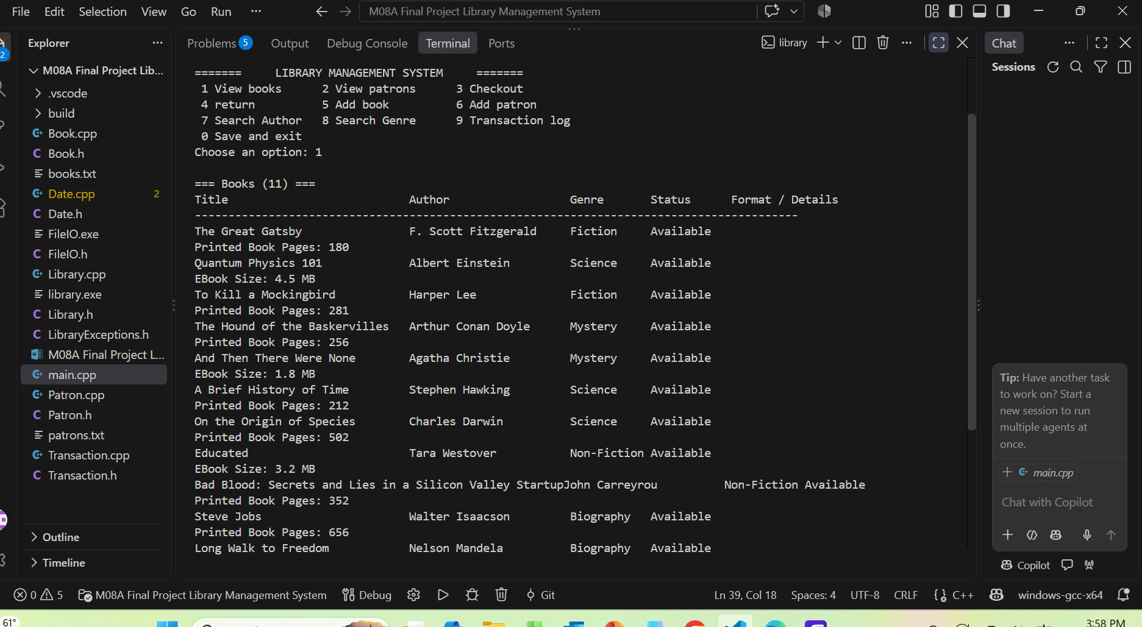
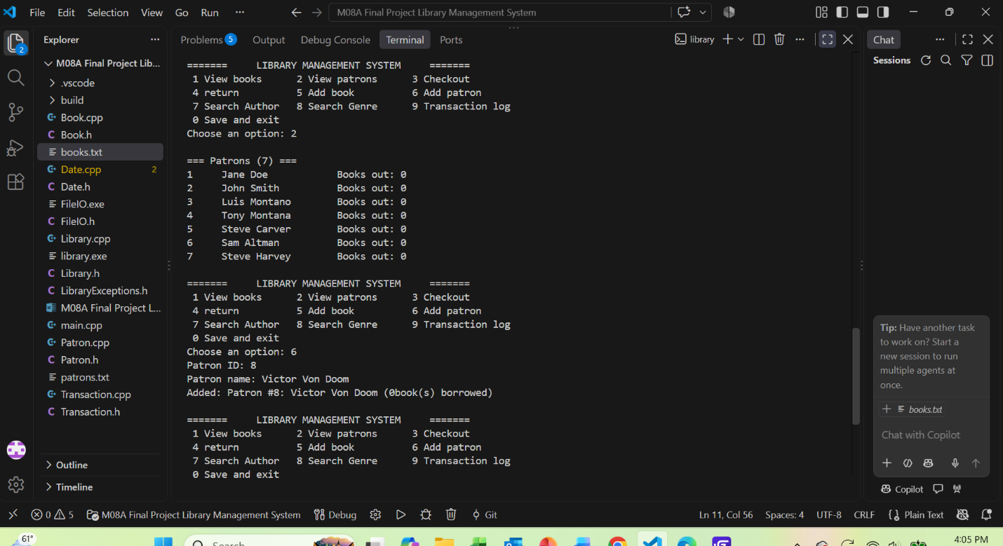
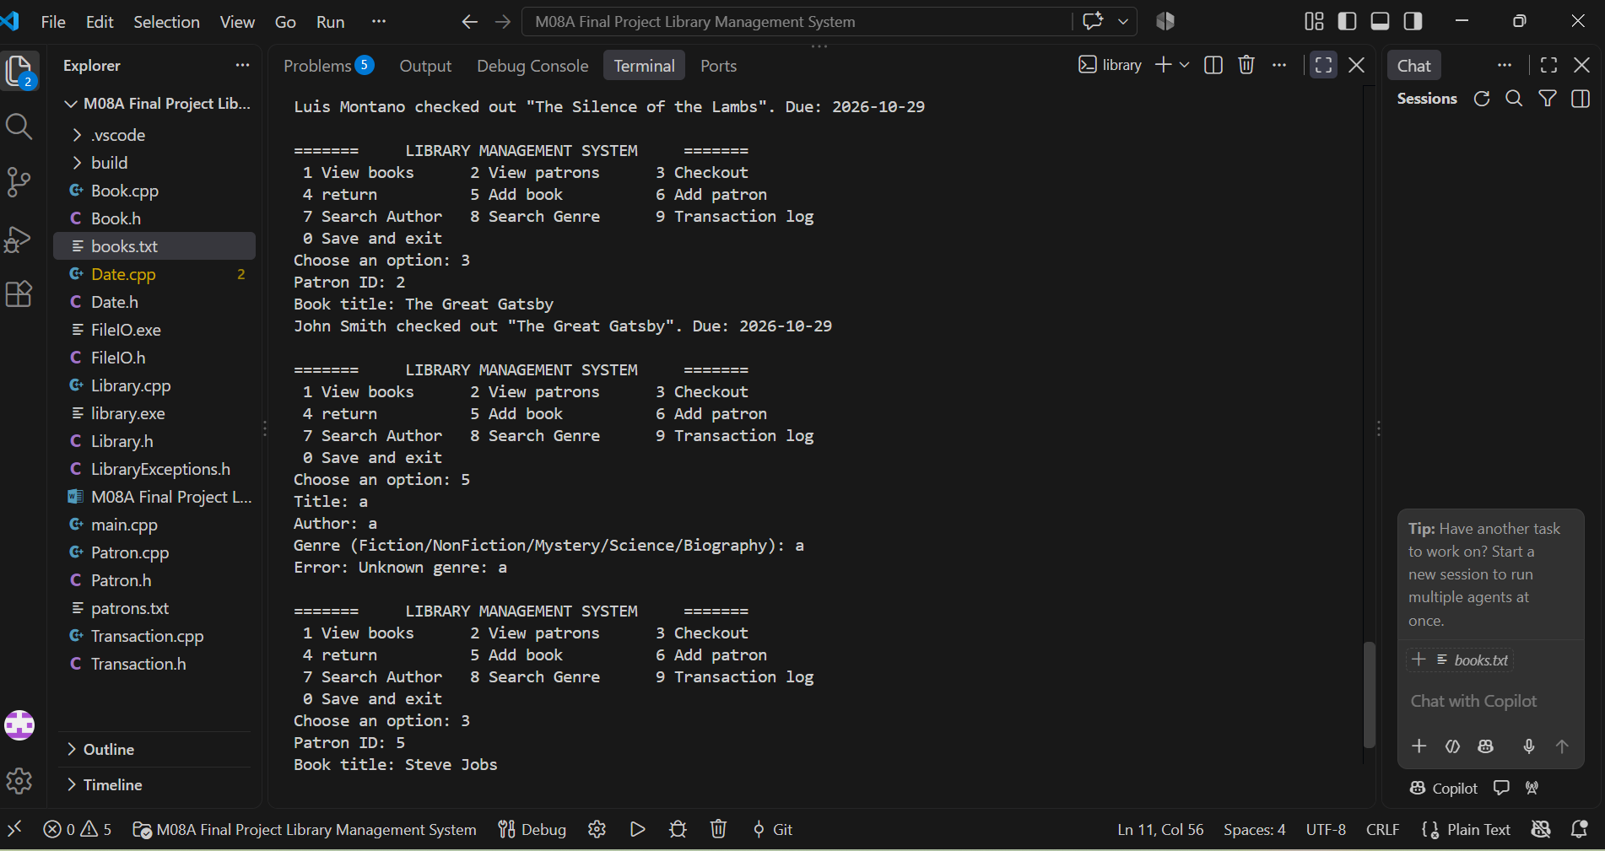
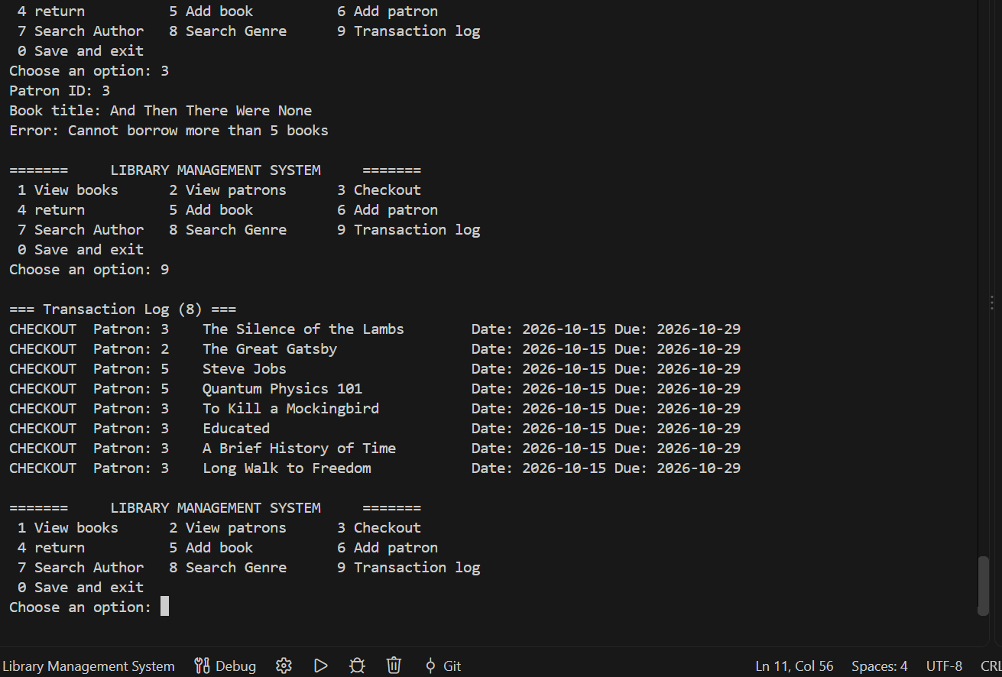
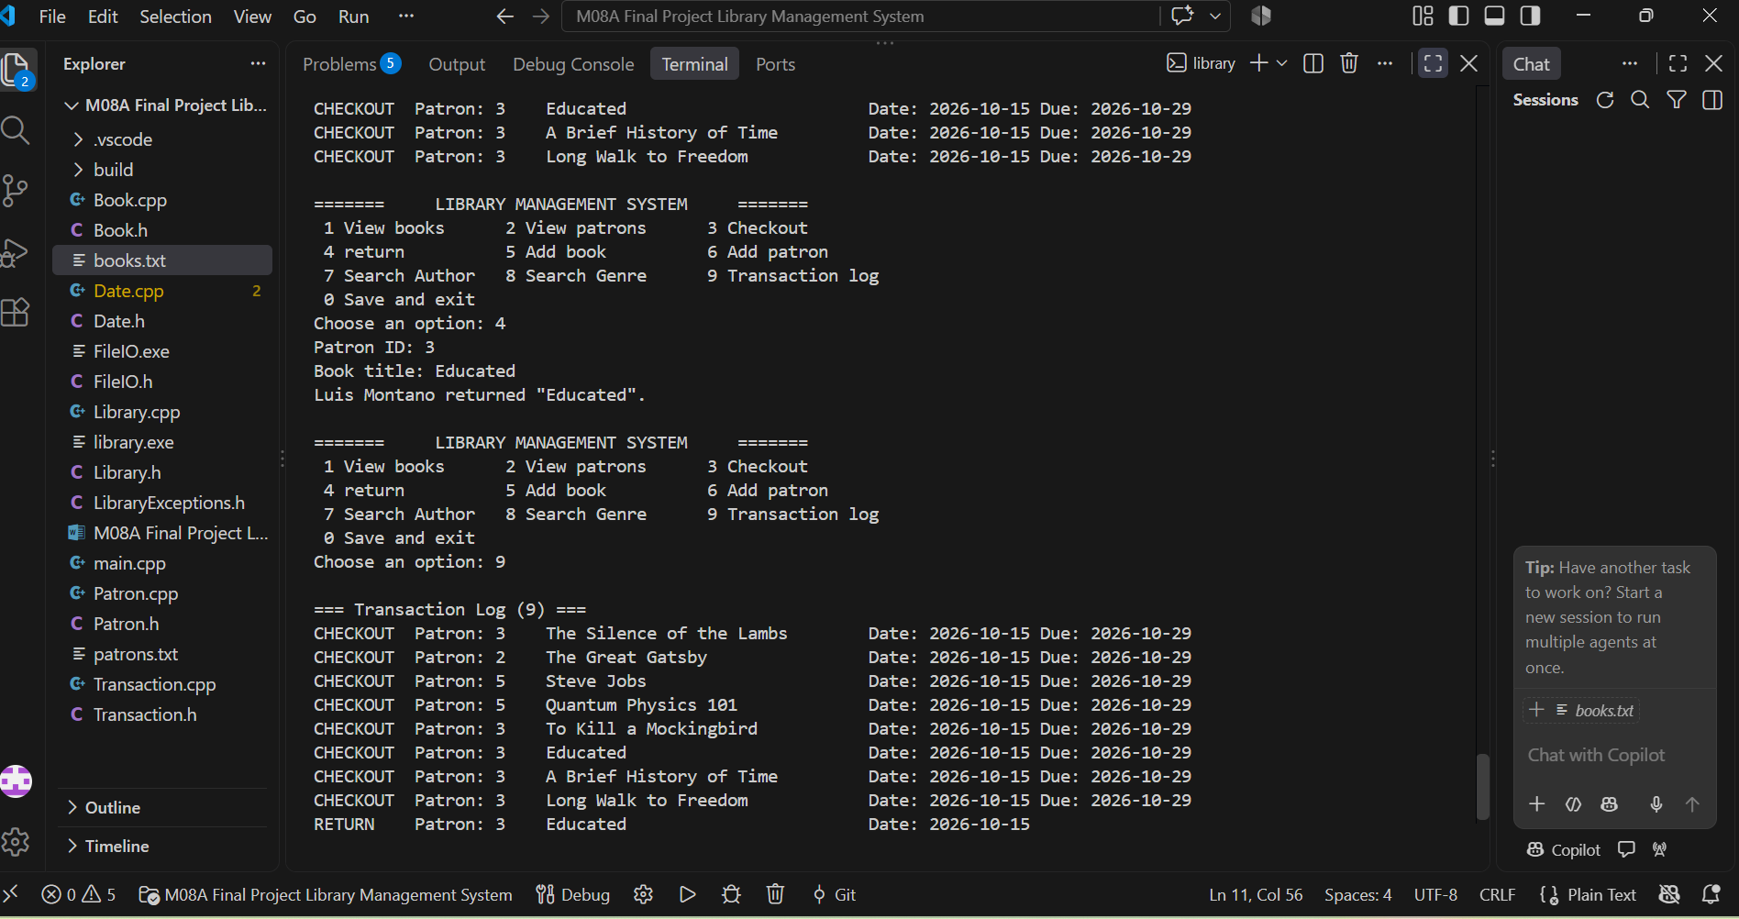

6 GitHub URL

Optional GitHub URL

